Router 1st

|  |
| --- |
| Router>enable  Router#configure terminal  Router(config)#hostname Router1  Router1(config)#interface FastEthernet0/0  Router1(config-if)#ip address 192.168.10.1 255.255.255.0  Router1(config-if)#no shutdown  Router1(config-if)#interface Serial0/0/0  Router1(config-if)#ip address 10.0.0.1 255.0.0.0  Router1(config-if)#no shutdown  Router1(config-if)#exit  Router1(config)#router eigrp 100  Router1(config-router)#network 192.168.10.0 0.0.0.255  Router1(config-router)#network 10.0.0.0 0.255.255.255  Router1(config-router)#no auto-summary  Router1(config-router)#exit  Router1(config)#exit  Router1#write memory |

Router 2

|  |
| --- |
| Router>enable  Router#configure terminal  Router(config)#hostname Router2  Router2(config)#interface FastEthernet0/0  Router2(config-if)#ip address 192.168.11.1 255.255.255.0  Router2(config-if)#no shutdown  Router2(config-if)#interface Serial0/0/0  Router2(config-if)#ip address 10.0.0.2 255.0.0.0  Router2(config-if)#no shutdown  Router2(config-if)#interface Serial0/0/1  Router2(config-if)#ip address 11.0.0.1 255.0.0.0  Router2(config-if)#no shutdown  Router2(config-if)#exit  Router2(config)#router eigrp 100  Router2(config-router)#network 192.168.11.0 0.0.0.255  Router2(config-router)#network 10.0.0.0 0.255.255.255  Router2(config-router)#network 11.0.0.0 0.255.255.255  Router2(config-router)#ex  Router2(config-router)#exit  Router2(config)#exit  Router2#write memory |

Router 3rd

|  |
| --- |
| Router>enable  Router#configure terminal  Router(config)#hostname Router3  Router3(config)#interface FastEthernet0/0  Router3(config-if)#ip address 192.168.12.1 255.255.255.0  Router3(config-if)#no shutdown  Router3(config-if)#interface Serial0/0/0  Router3(config-if)#ip address 11.0.0.2 255.0.0.0  Router3(config-if)#no shutdown  Router3(config-if)#interface Serial0/0/1  Router3(config-if)#ip address 12.0.0.1 255.0.0.0  Router3(config-if)#no shutdown  Router3(config-if)#exit  Router3(config)#router eigrp 100  Router3(config-router)#network 192.168.12.0 0.0.0.255  Router3(config-router)#network 11.0.0.0 0.255.255.255  Router3(config-router)#network 12.0.0.0 0.255.255.255  Router3(config-router)#no auto-summary  Router3(config-router)#exit  Router3(config)#exit  Router3#write memory |

Router 4th

|  |
| --- |
| Router>enable  Router#configure terminal  Router(config)#hostname Router4  Router4(config)#interface FastEthernet0/0  Router4(config-if)#ip address 192.168.13.1 255.255.255.0  Router4(config-if)#no shutdown  Router4(config-if)#interface Serial0/0/0  Router4(config-if)#ip address 12.0.0.2 255.0.0.0  Router4(config-if)#no shutdown  Router4(config-if)#exit  Router4(config)#router eigrp 100  Router4(config-router)#network 192.168.13.0 0.0.0.255  Router4(config-router)#network 12.0.0.0 0.255.255.255  Router4(config-router)#no auto-summary  Router4(config-router)#exit  Router4(config)#exit  Router4#write memory |

Verification Command

|  |
| --- |
| Router#show ip eigrp neighbors // Verify EIGRP neighbors are established  Router#show ip route // Check routing table for EIGRP-learned routes  Router#show ip eigrp topology // Display EIGRP topology table  Router#ping <destination IP> // Test connectivity to other routers' networks |

**EIGRP 4 router shortest path**

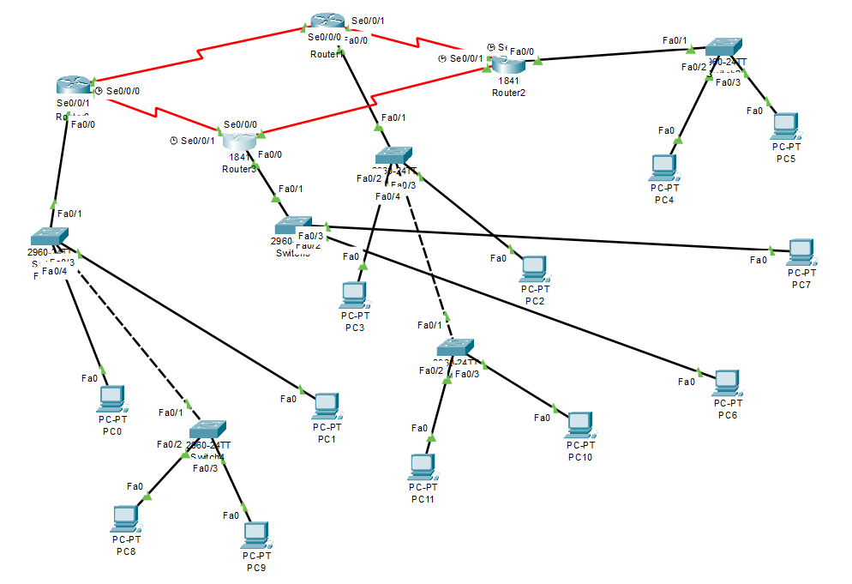

Router 1st

|  |
| --- |
| Router1>en  Router1#conf t  Enter configuration commands, one per line. End with CNTL/Z.  Router1(config)#interface FastEthernet0/0  Router1(config-if)#ip address 192.168.10.1 255.255.255.0  Router1(config-if)#no shutdown  Router1(config-if)#interface Serial0/0/0  Router1(config-if)#ip address 10.0.0.1 255.0.0.0  Router1(config-if)#no shutdown  Router1(config-if)#interface Serial0/0/1  Router1(config-if)#ip address 13.0.0.1 255.0.0.0  Router1(config-if)#no shutdown  Router1(config-if)#exit  Router1(config)#router eigrp 100  Router1(config-router)#network 192.168.10.0 0.0.0.255  Router1(config-router)#network 10.0.0.0 0.255.255.255  Router1(config-router)#network 13.0.0.0 0.255.255.255  Router1(config-router)#no auto-summary  Router1(config-router)#ex  Router1(config)#ex  Router1#  %SYS-5-CONFIG_I: Configured from console by console  Router1#wr  Building configuration...  [OK]  Router1#  %DUAL-5-NBRCHANGE: IP-EIGRP 100: Neighbor 13.0.0.2 (Serial0/0/1) is up: new adjacency |

Router 2nd

|  |
| --- |
| Router>en  Router#conf t  Enter configuration commands, one per line. End with CNTL/Z.  Router(config)#hostname Router2  Router2(config)#interface FastEthernet0/0  Router2(config-if)#ip address 192.168.11.1 255.255.255.0  Router2(config-if)#no shutdown  Router2(config-if)#  %LINK-5-CHANGED: Interface FastEthernet0/0, changed state to up  %LINEPROTO-5-UPDOWN: Line protocol on Interface FastEthernet0/0, changed state to up  Router2(config-if)#interface Serial0/0/0  Router2(config-if)#ip address 10.0.0.2 255.0.0.0  Router2(config-if)#no shutdown  Router2(config-if)#  %LINK-5-CHANGED: Interface Serial0/0/0, changed state to up  Router2(config-if)#  %LINEPROTO-5-UPDOWN: Line protocol on Interface Serial0/0/0, changed state to up  Router2(config-if)#interface Serial0/0/1  Router2(config-if)#ip address 11.0.0.1 255.0.0.0  Router2(config-if)#no shutdown  %LINK-5-CHANGED: Interface Serial0/0/1, changed state to down  Router2(config-if)#exit  Router2(config)#router eigrp 100  Router2(config-router)#network 192.168.11.0 0.0.0.255  Router2(config-router)#network 10.0.0.0 0.255.255.255  Router2(config-router)#  %DUAL-5-NBRCHANGE: IP-EIGRP 100: Neighbor 10.0.0.1 (Serial0/0/0) is up: new adjacency  Router2(config-router)#network 11.0.0.0 0.255.255.255  Router2(config-router)#no auto-summary  Router2(config-router)#  %DUAL-5-NBRCHANGE: IP-EIGRP 100: Neighbor 10.0.0.1 (Serial0/0/0) resync: summary configured  Router2(config-router)#ex  Router2(config)#ex  Router2#  %SYS-5-CONFIG_I: Configured from console by console  Router2#wr  Building configuration...  [OK]  Router2#  %LINK-5-CHANGED: Interface Serial0/0/1, changed state to up |

Router 3rd

|  |
| --- |
| Router>en  Router#conf t  Enter configuration commands, one per line. End with CNTL/Z.  Router(config)#hostname Router2  Router2(config)#interface FastEthernet0/0  Router2(config-if)#ip address 192.168.11.1 255.255.255.0  Router2(config-if)#no shutdown  Router2(config-if)#  %LINK-5-CHANGED: Interface FastEthernet0/0, changed state to up  %LINEPROTO-5-UPDOWN: Line protocol on Interface FastEthernet0/0, changed state to up  Router2(config-if)#interface Serial0/0/0  Router2(config-if)#ip address 10.0.0.2 255.0.0.0  Router2(config-if)#no shutdown  Router2(config-if)#  %LINK-5-CHANGED: Interface Serial0/0/0, changed state to up  Router2(config-if)#  %LINEPROTO-5-UPDOWN: Line protocol on Interface Serial0/0/0, changed state to up  Router2(config-if)#interface Serial0/0/1  Router2(config-if)#ip address 11.0.0.1 255.0.0.0  Router2(config-if)#no shutdown  %LINK-5-CHANGED: Interface Serial0/0/1, changed state to down  Router2(config-if)#exit  Router2(config)#router eigrp 100  Router2(config-router)#network 192.168.11.0 0.0.0.255  Router2(config-router)#network 10.0.0.0 0.255.255.255  Router2(config-router)#  %DUAL-5-NBRCHANGE: IP-EIGRP 100: Neighbor 10.0.0.1 (Serial0/0/0) is up: new adjacency  Router2(config-router)#network 11.0.0.0 0.255.255.255  Router2(config-router)#no auto-summary  Router2(config-router)#  %DUAL-5-NBRCHANGE: IP-EIGRP 100: Neighbor 10.0.0.1 (Serial0/0/0) resync: summary configured  Router2(config-router)#ex  Router2(config)#ex  Router2#  %SYS-5-CONFIG_I: Configured from console by console  Router2#wr  Building configuration...  [OK]  Router2#  %LINK-5-CHANGED: Interface Serial0/0/1, changed state to up |

Router 4th

|  |
| --- |
| Router>en  Router#conf  Configuring from terminal, memory, or network [terminal]?  Enter configuration commands, one per line. End with CNTL/Z.  Router(config)#conf t  %Invalid hex value  Router(config)#interface FastEthernet0/0  Router(config-if)#ip address 192.168.13.1 255.255.255.0  Router(config-if)#no shutdown  Router(config-if)#interface Serial0/0/0  Router(config-if)#ip address 12.0.0.2 255.0.0.0  Router(config-if)#no shutdown  Router(config-if)#interface Serial0/0/1  Router(config-if)#ip address 13.0.0.2 255.0.0.0  Router(config-if)#no shutdown  Router(config-if)#exit  Router(config)#router eigrp 100  Router(config-router)#network 192.168.13.0 0.0.0.255  Router(config-router)#network 12.0.0.0 0.255.255.255  Router(config-router)#network 13.0.0.0 0.255.255.255  Router(config-router)#  %DUAL-5-NBRCHANGE: IP-EIGRP 100: Neighbor 13.0.0.1 (Serial0/0/1) is up: new adjacency  Router(config-router)#no auto-summary  Router(config-router)#ex  Router(config)#ex  Router#  %SYS-5-CONFIG_I: Configured from console by console  Router#wr  Building configuration...  [OK]  Router# |